Name: Pranali Sonawane
Subject: MCSA
Date: 8-12-2025
Lab : DHCP Config
Server 1:
- Dashboard Add Role and Features Next Next Click on DHCP Server(Add Feature) Click on Install Restart
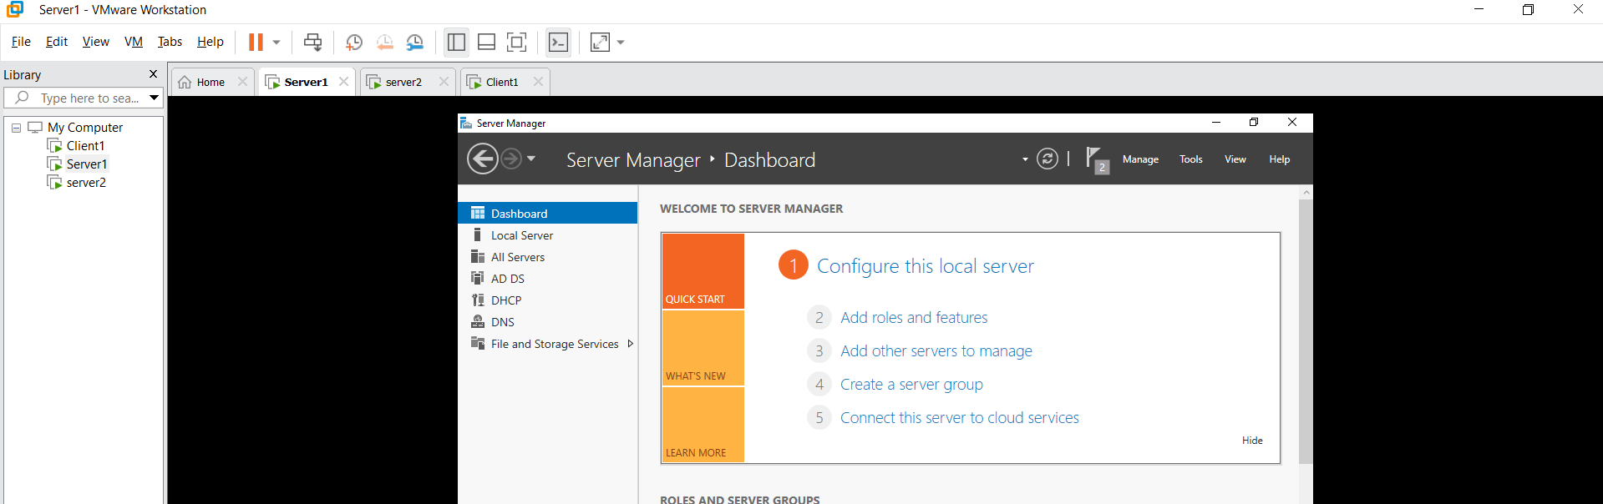

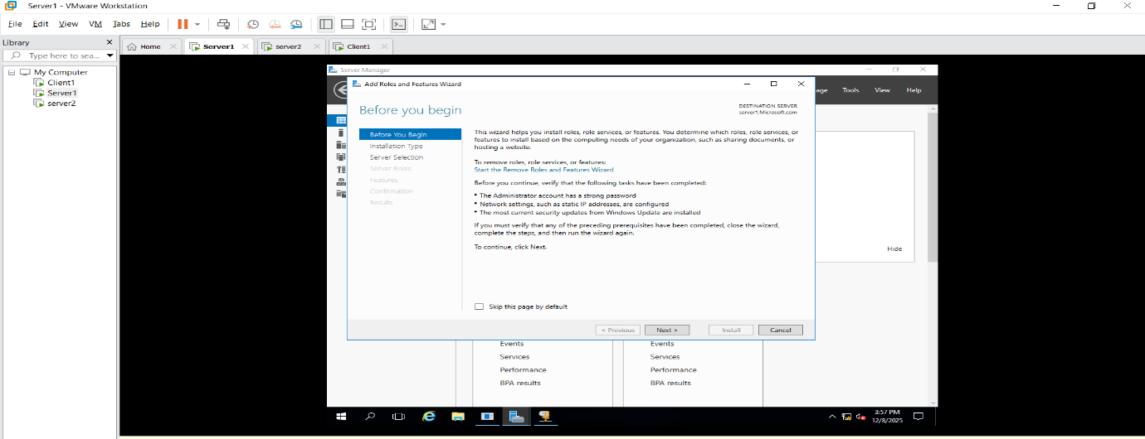
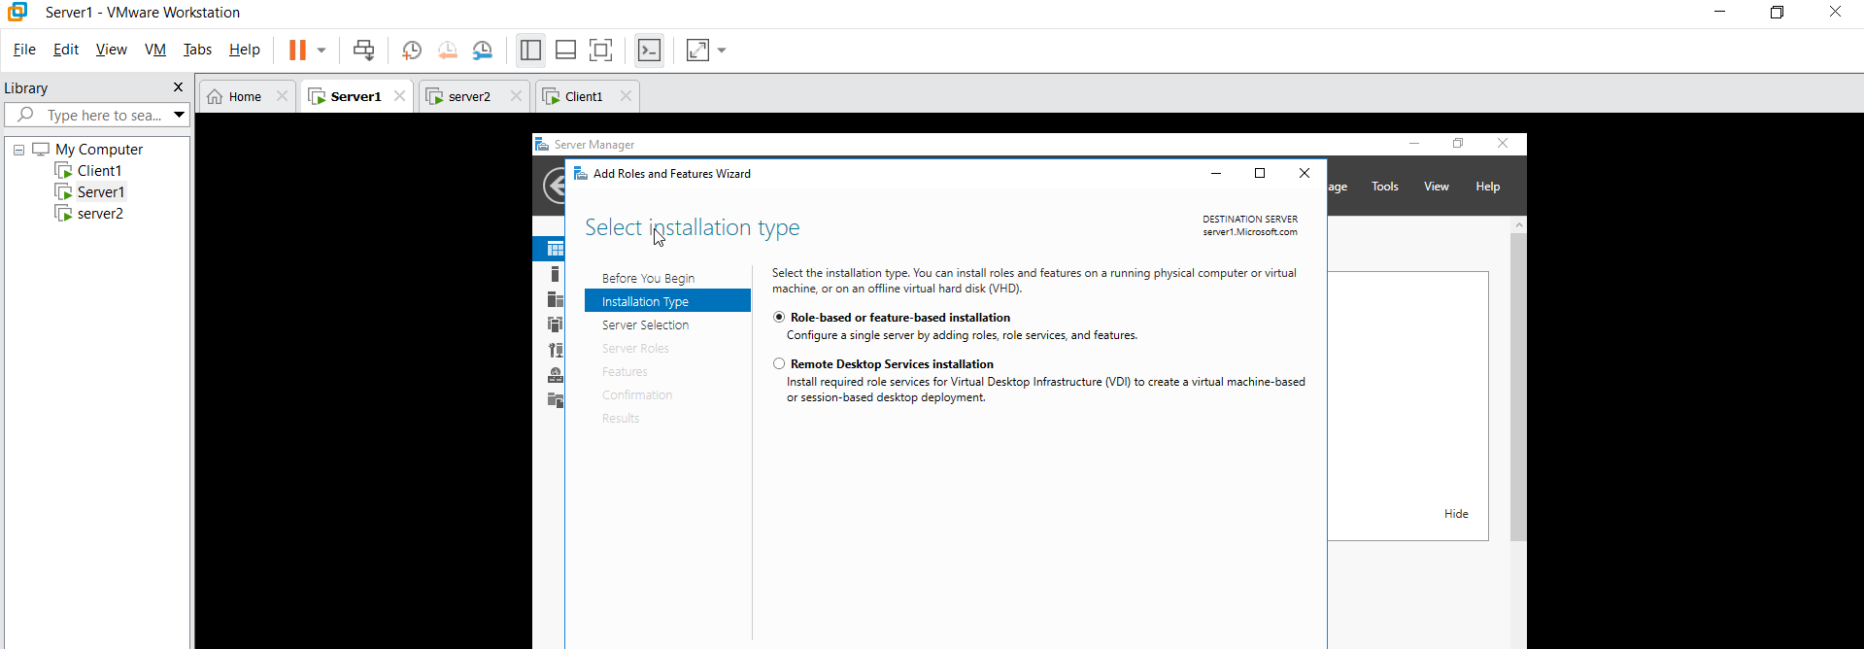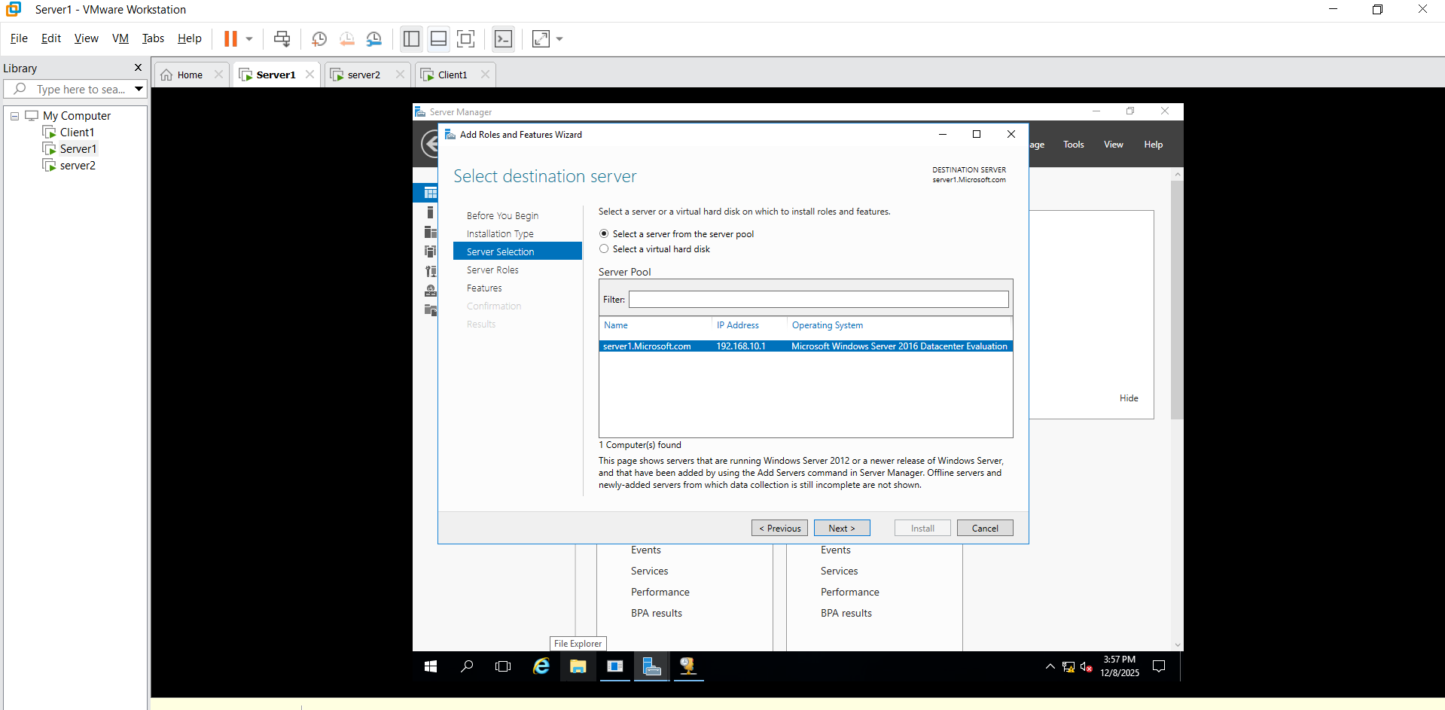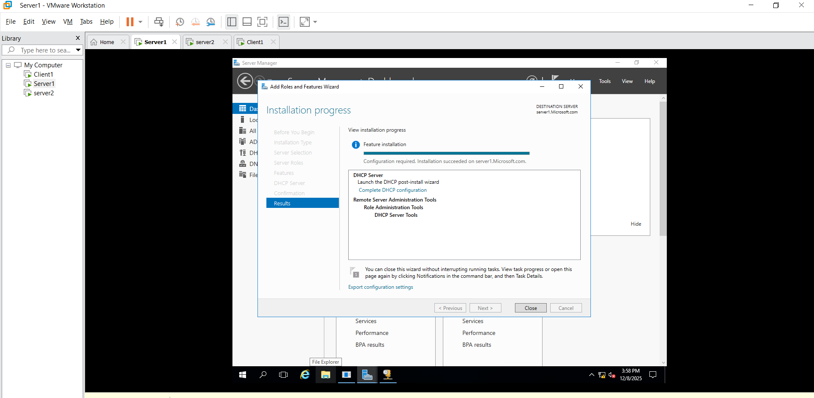
- Tools DHCP IPV4 Create new Scope Name Microsoft start IP: 192.168.10.31 , end IP : 192.168.10.40 next Excluded : start IP : 192.168.10.32 , end IP: 192.168.10.32 days: 100 yes Router DG: 192.168.10.254 DNS Server next WINS Server next

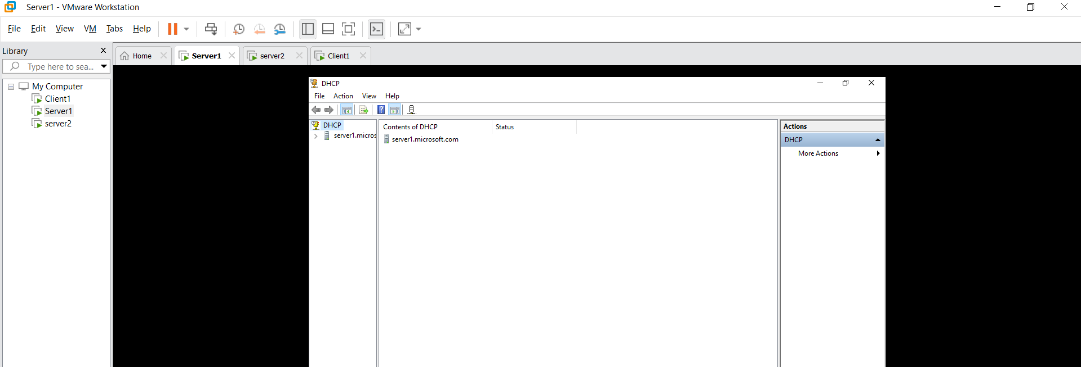

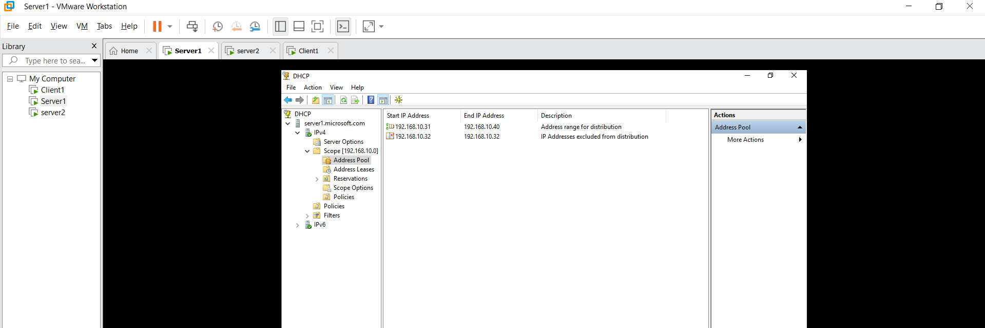
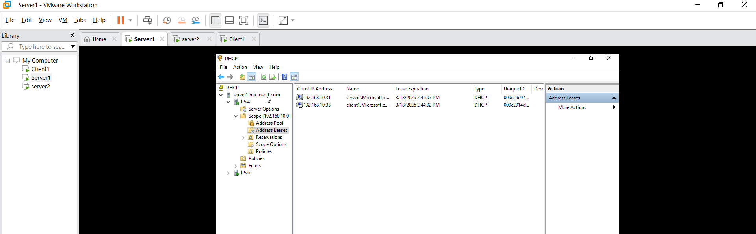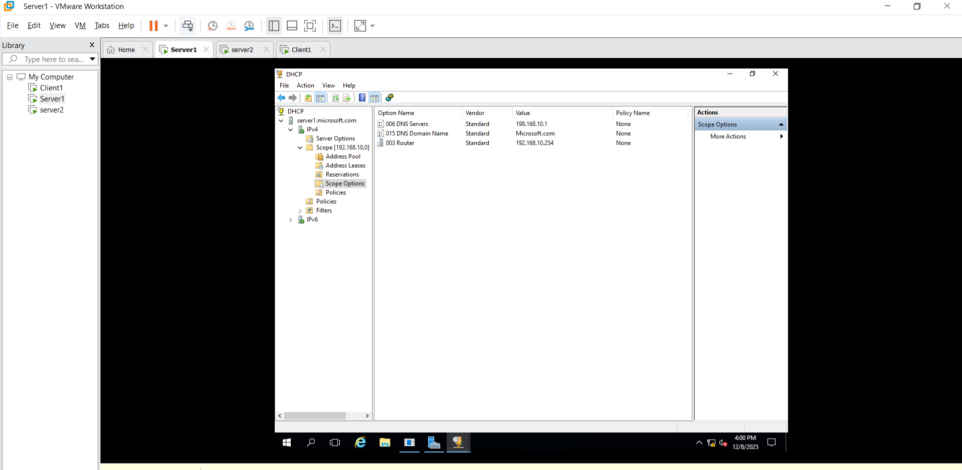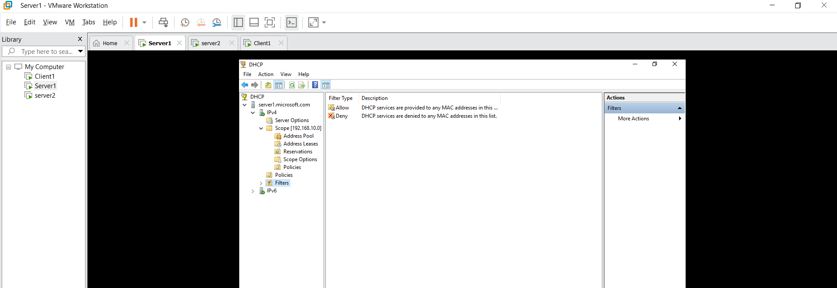
Server2 : Login Administrator Load Server Ethernet0 Properties Click on Automatic IP then Ethernet0 right click on disable then enable.
Then go cmd : ipconfig/all
IPV4: 192.168.10.31
DG: 192.168.10.254
Client 1 : Login Administrator Run ncpa.cpl Ethernet0 Propertise Click on Automatic IP then Ethernet0 right click on disable then enable.
Then go cmd : ipconfig/all
IPV4: 192.168.10.33
DG: 192.168.10.254
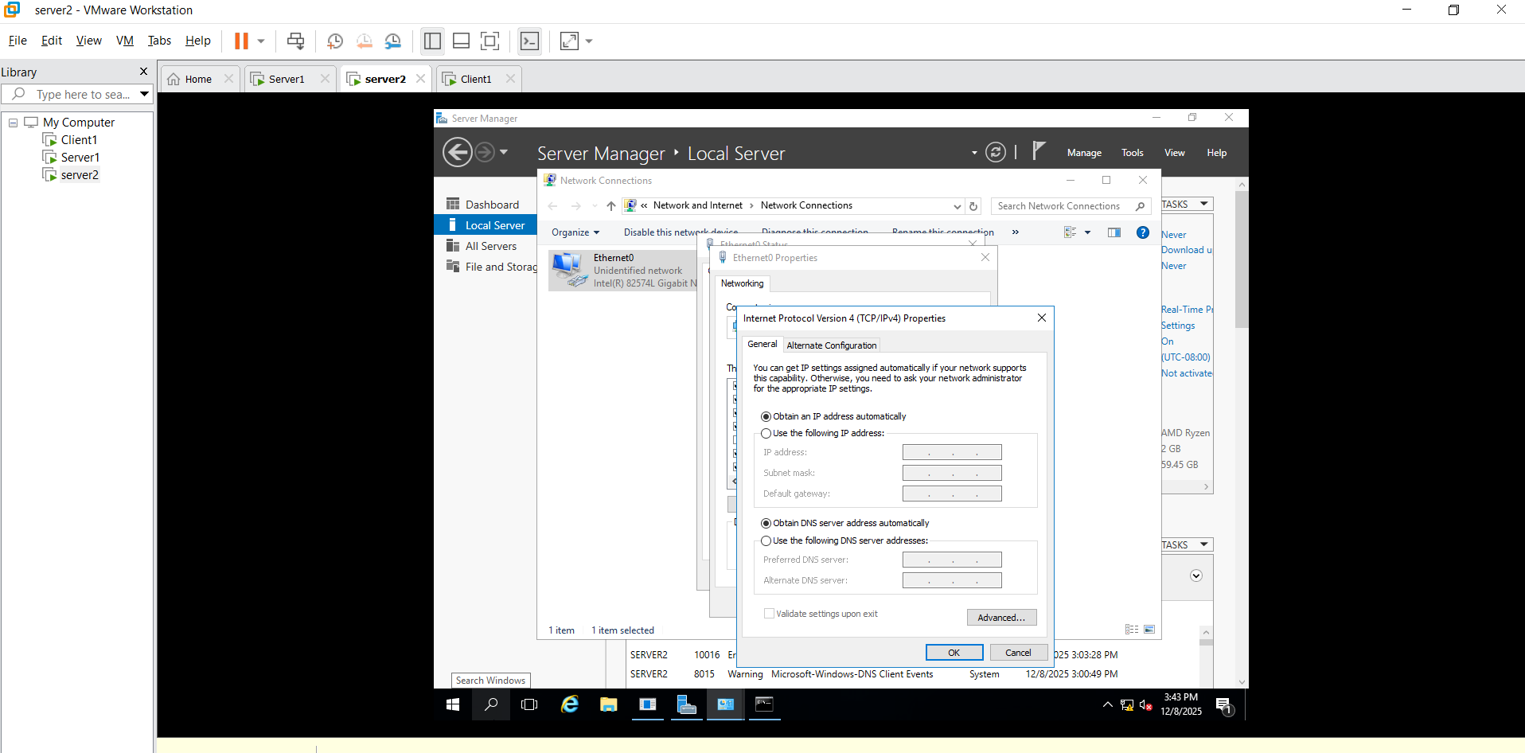

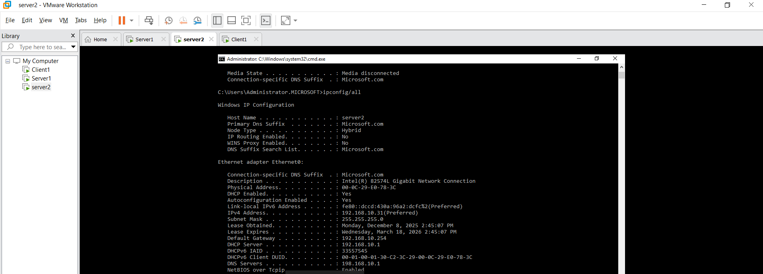
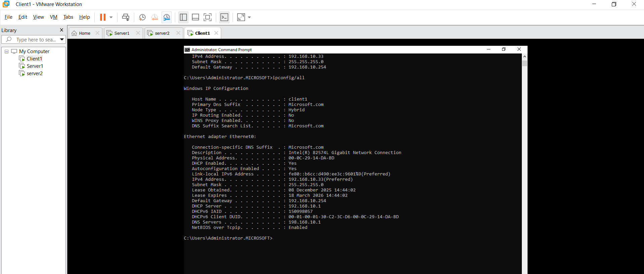

But Problem is their :-server1:
- IPV4 refresh
- That time excluded is not add how to add then :
Address pool New Exclusion Range:
start IP: 192.168.10.32
End IP: 192.168.10.32
- Default-gateway not added then go to the Scope Option click on 003 Router give 192.168.10.254
- Last Server2 cmd ipconfig\release
ipconfig\renew
Client1 cmd ipconfig\release
ipconfig\renew
5.Then check ipconfig/all in Server2 and Client1.

